**Experiment No:** 06

**Experiment name:**  Process Handling in Linux Mint.

**Advantages:**

* Increase Skills.
* Process Handling
* Industry uses of Linux, Cloud Computing and Virtualization.
* To provide an introduction in Linux environment.

**Experiment:**

At first I open terminal session.Then I have done some method to kill processes.Here is this process:

TOP: List processes

PS AUX:

List all processe in detail running on the system including users ,process ID (PID) ,and name of process .Using this ,one can view their process list and if necessary ,kill unnecessary or stalled processes.

Kill/Killall:

i)Kill PID(ID):PID is a number referencing the offending process.One should obtain the PID from a command line ps aux.If a process refuses to die ,one can alternatively specify kill -9 PID which should terminate the process by any means ,even unclearly or if it will mess up the system.

ii)KILLALL PROGRAM:

Killall kills *by name* all instances of said program.If there are for example 3 firefox sessions.Kill would simply take the specified PID of the offending firefox process you wish to kill ,and kill that one only.

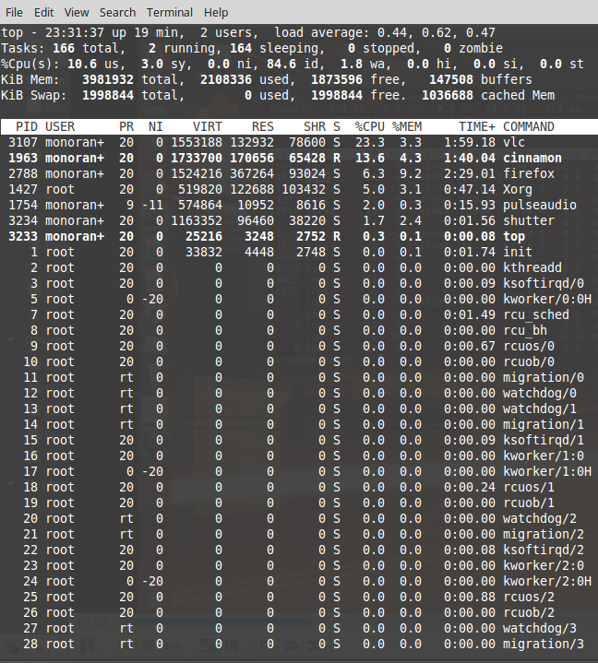

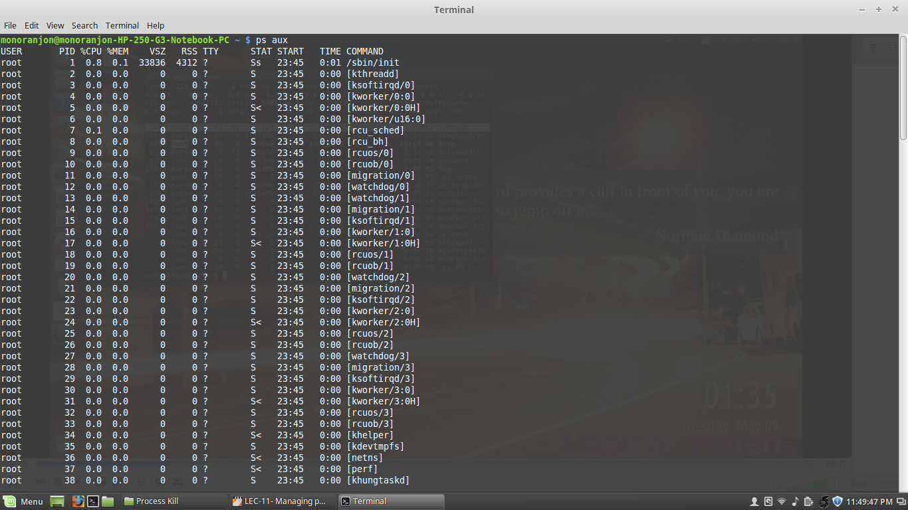

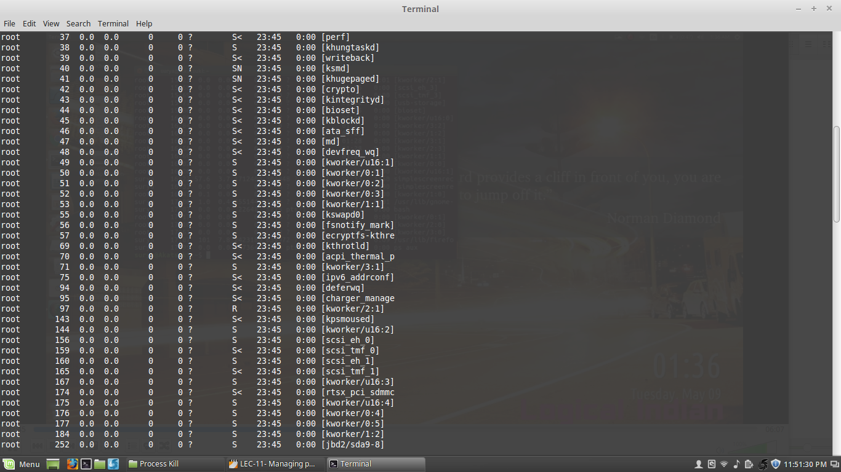

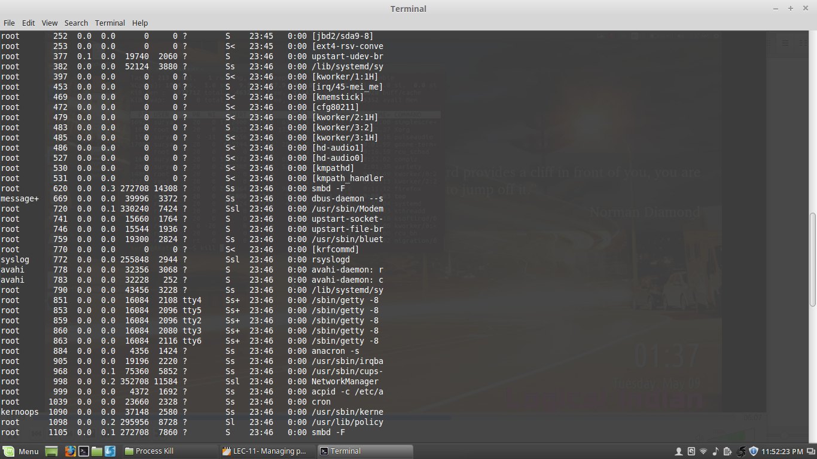

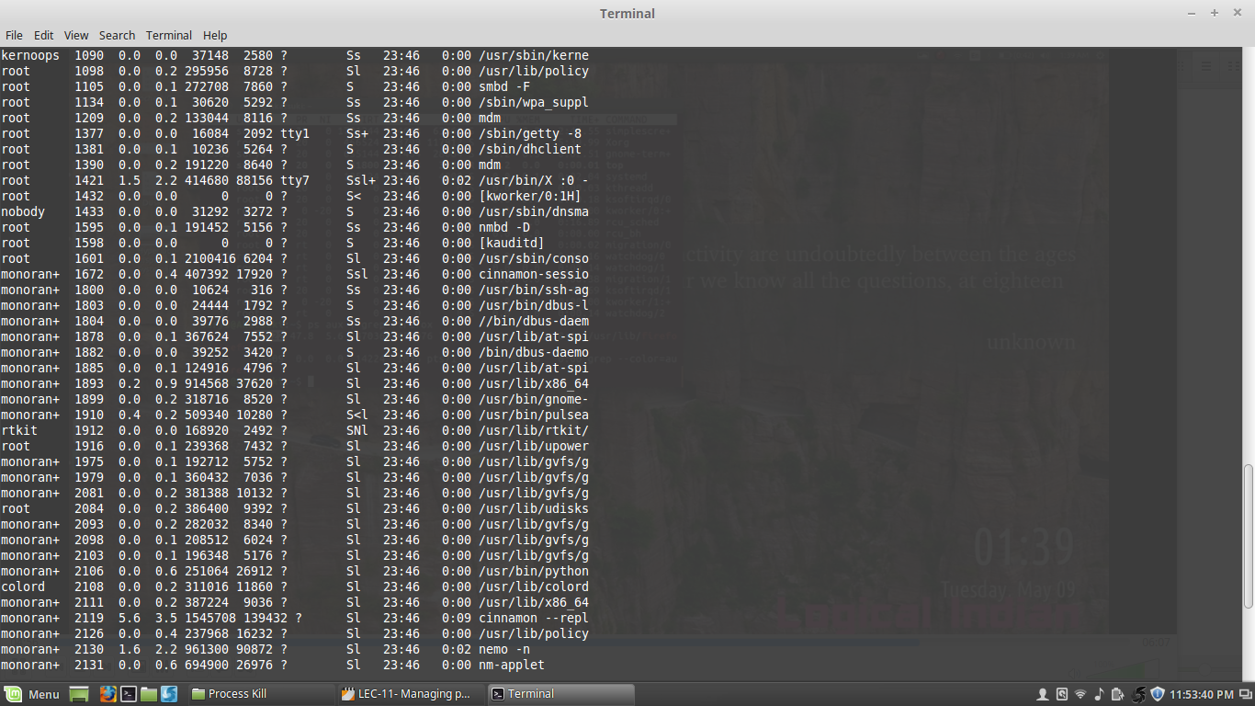

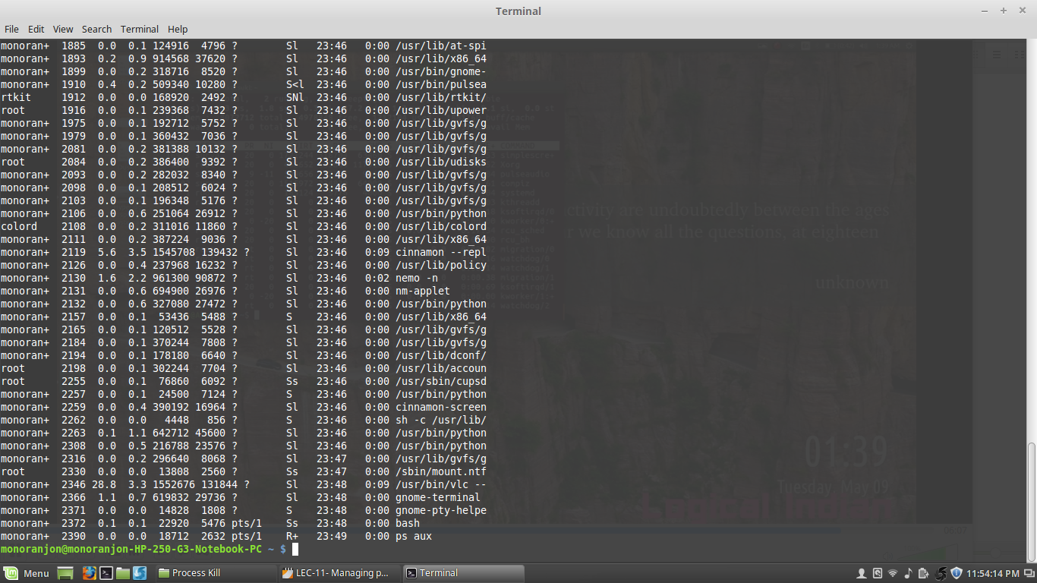

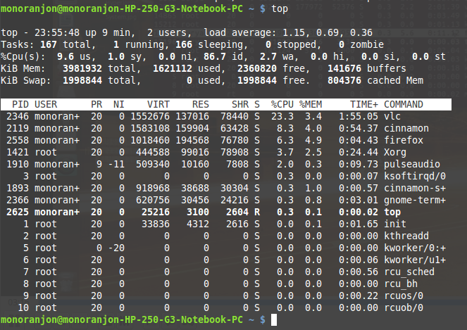

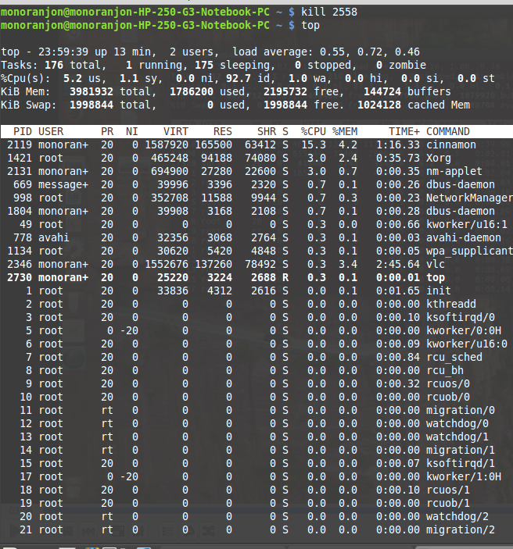

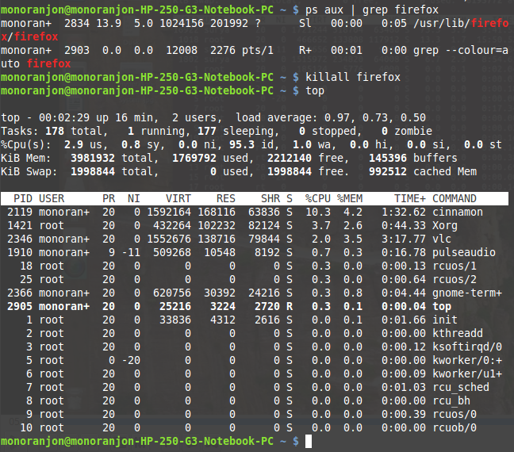

**Conclusion:**

Linux mint is highly secured system. Linux distributions are highly customizable.I have done process handling in linux mint.One thing you have to conscious that linux is a case sensitive to perform commands in linux terminal.